**GROCERY WEBAPP**

**Using MERN**

By :

Dhanush Kumar S-2021115026

Hariharan S- 2021115039

Yuvaraj V-2021115125

Yazhiniyan P-2021115306

**Introduction**

The Grocery Web Application provides a comprehensive online platform for browsing, selecting, and purchasing groceries. This report focuses on the details of each web page, including their design, functionalities, and user interactions.

**Login and Registration Pages**

The Login and Registration Pages handle user authentication securely. The Login Page allows users to access their accounts, while the Registration Page enables new users to sign up. Both pages feature validation to ensure secure and accurate access, enhancing the platform's overall security.

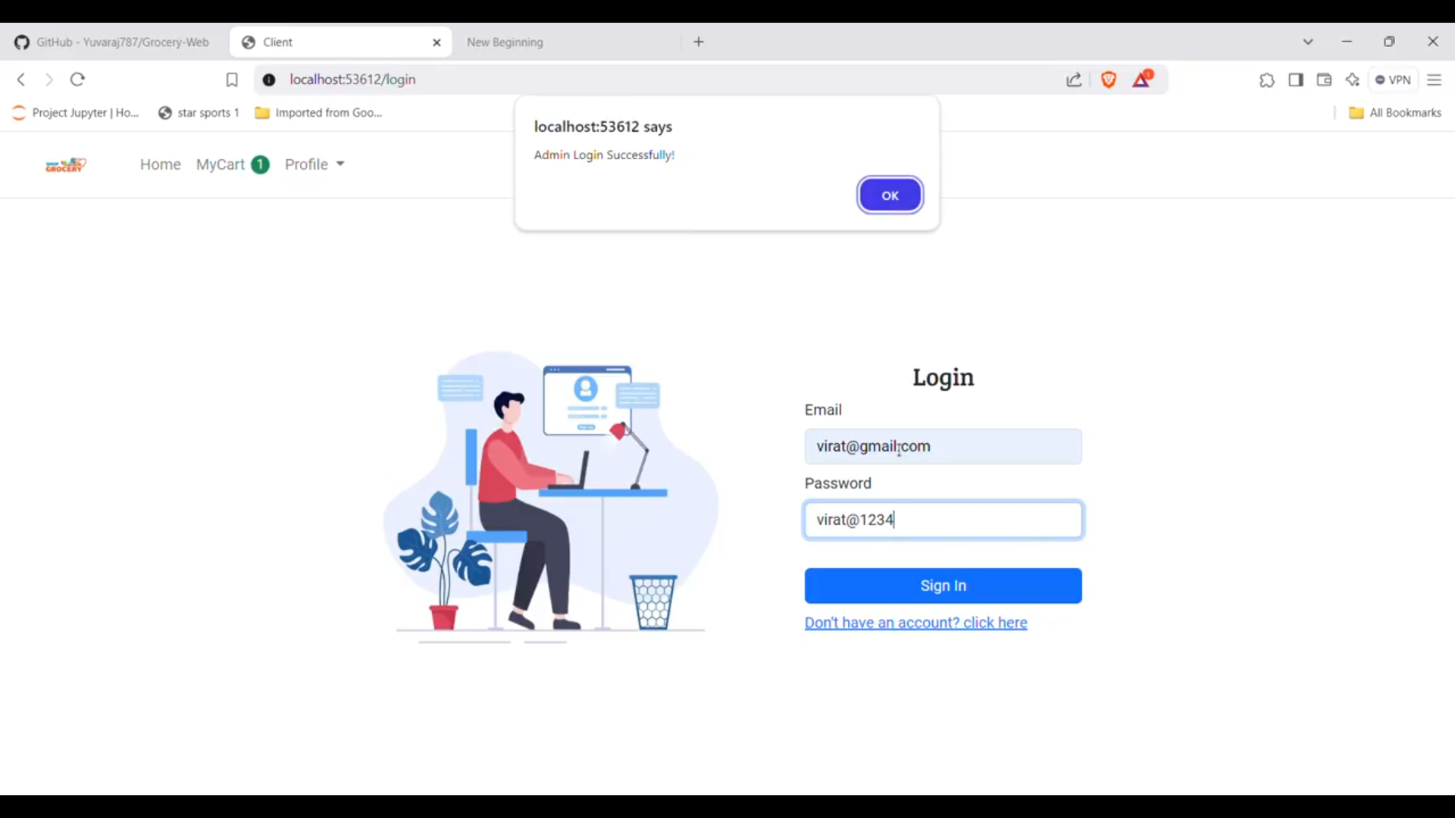

**Fig .1 Login Page**

**Home Page:**

The Home Page is the entry point to the Grocery Web Application, featuring an intuitive design with easy access to essential sections like.Products, Cart, and Profile through a navigation bar. A dynamic banner .highlights promotions, while featured products and category tiles provide a seamless browsing experience. The strategically placed search bar ensures users can quickly find specific items, making the Home Page an engaging and efficient starting point for their shopping journey.

**Fig .2 Home Page**

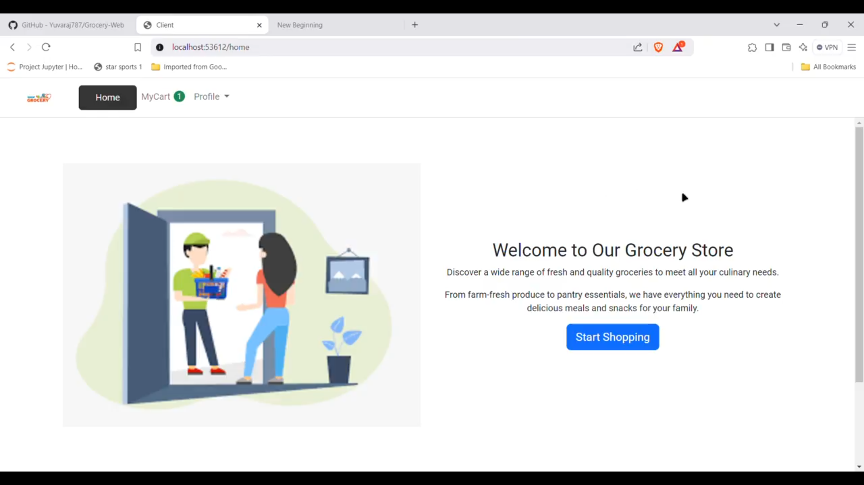

**Product Listing Page**

The Product Listing Page displays all available groceries in an organized grid or list format. Each product shows key details such as the name, price, and availability. Users can refine their search using filters for categories, price ranges, and sorting options. Pagination enhances usability by managing extensive inventories, ensuring a smooth and personalized shopping experience.

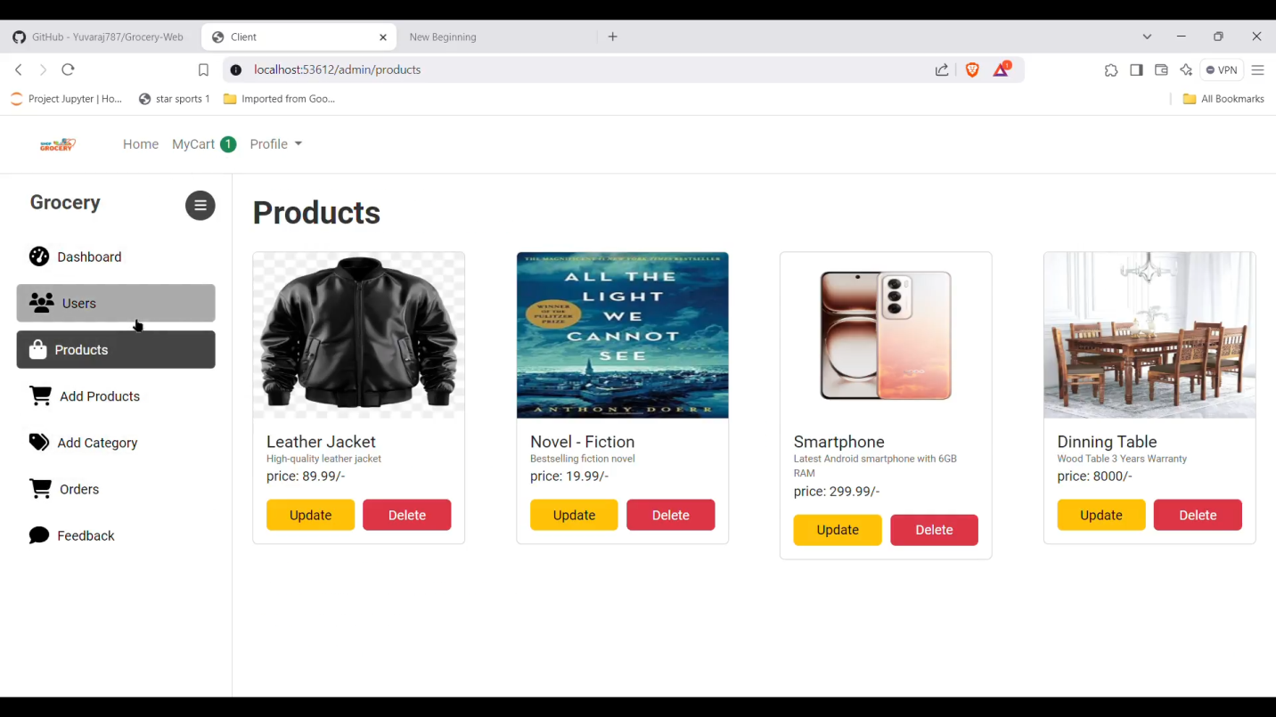

**Fig .3 Product Listing Page**

**Product Detail Page**

The Product Detail Page offers comprehensive information about selected products. High-resolution images, detailed descriptions, and specifications help users make informed decisions. Features like quantity selection and an “Add to Cart” button streamline the purchasing process. Additionally, customer reviews foster transparency and build trust in the product quality.

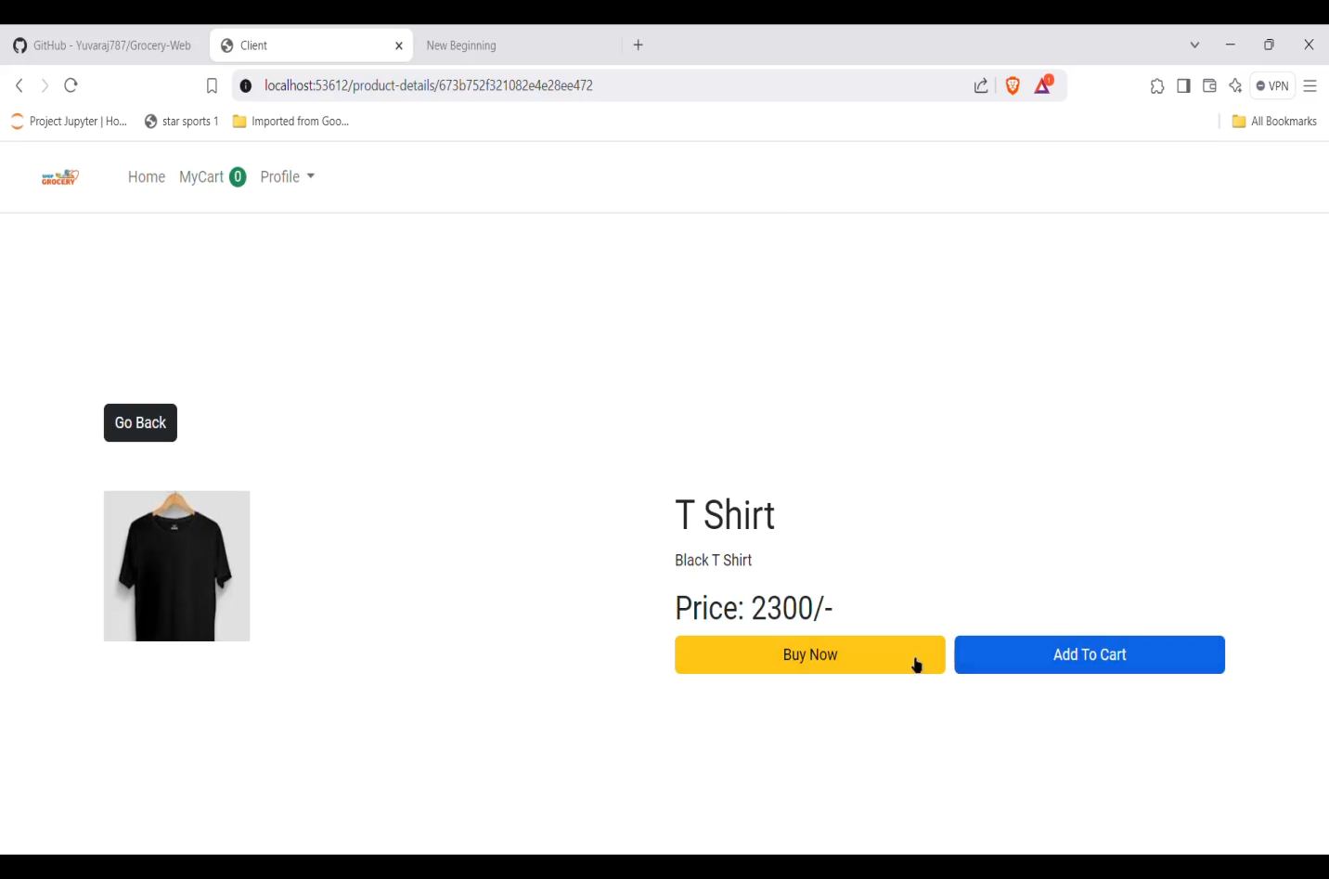

**Fig .4 Product Detail Page**

**Cart Page**

The Cart Page provides a summary of selected items, displaying their images, names, quantities, and prices. Users can adjust quantities or remove items, with changes reflected in the order summary. The “Proceed to Checkout” button simplifies transitioning to the purchase phase, ensuring users can manage their orders efficiently.

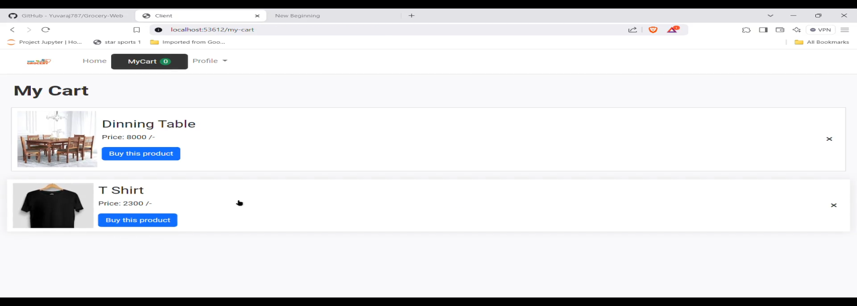

**Fig .5 Cart Page**

**Checkout Page**

The Checkout Page collects essential shipping and payment information through a user-friendly form. Users can review their order details and select their preferred payment method.

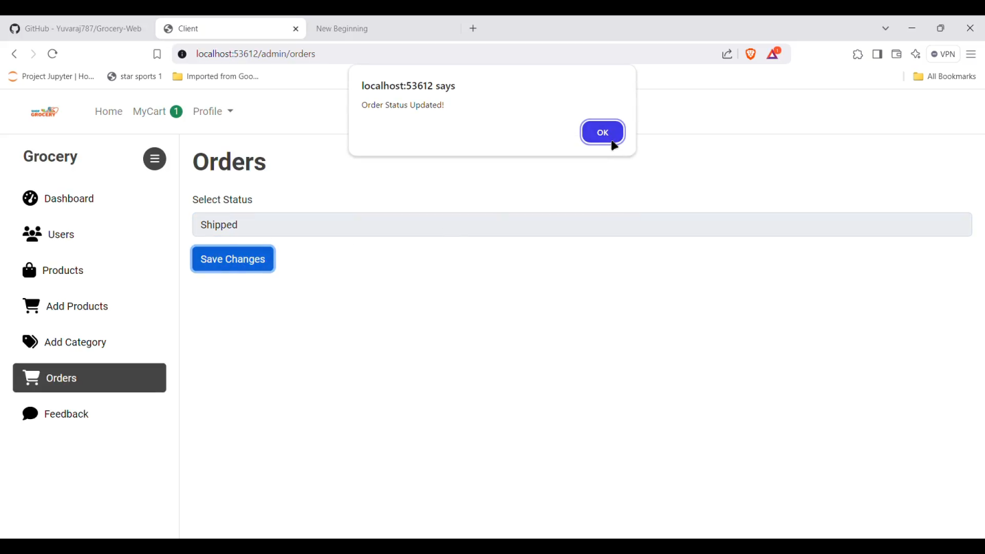

**Fig .6 Check Out Page**

Validation ensures accurate data entry, while a “Place Order” button finalizes the transaction, offering a secure and smooth checkout process.

**User Profile Page**

The User Profile Page allows registered users to manage their personal details and view order history. Users can update information, track past purchases, and change passwords.

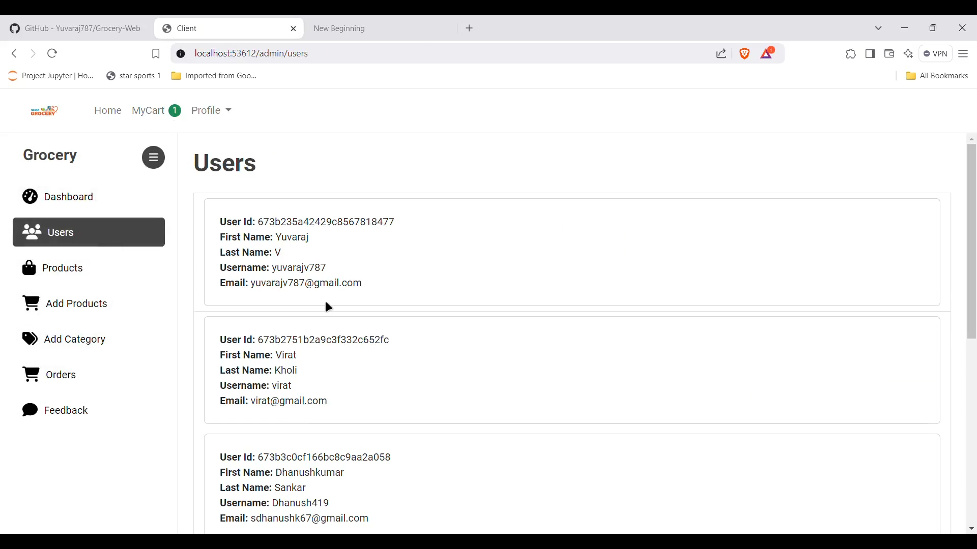

**Fig .7 User Page**

This personalized hub fosters trust and provides convenient access to account management features.

**Dashboard**

The Dashboard streamlines back-end operations, providing tools to manage products, users, and orders. Admins can add or update products, handle user accounts, and track order statuses. This page ensures efficient platform management, contributing to a smooth overall operation.

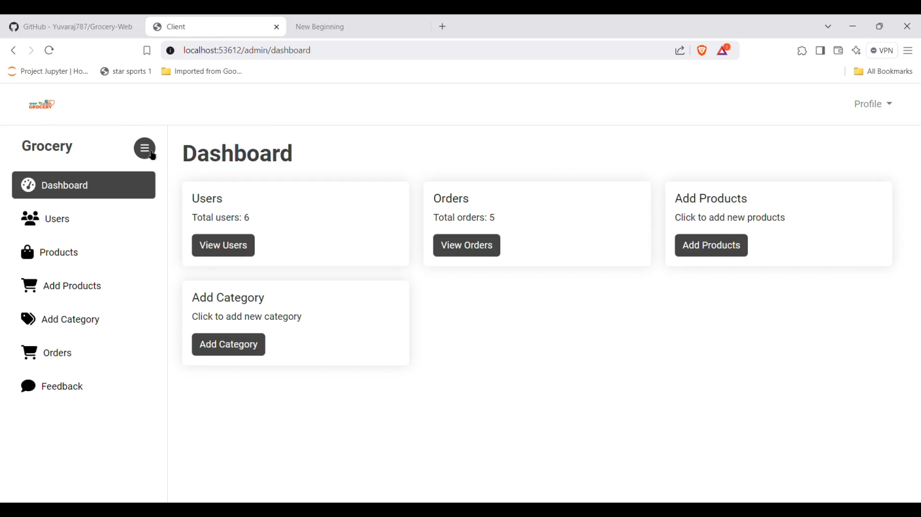

**Fig .8 Dashboard Page**

**Order Page**

The Order Page provides users with a comprehensive overview of their current and past orders. Each order entry includes essential details like the order date, total cost, and current status (e.g., pending, shipped, delivered). Users can click on an order to view item-specific information, including images, quantities, and prices. This functionality allows customers to track delivery progress and refer back to previous purchases for easy reordering. By offering clear insights into their purchase history, the Order Page fosters transparency and enhances user confidence in the platform.

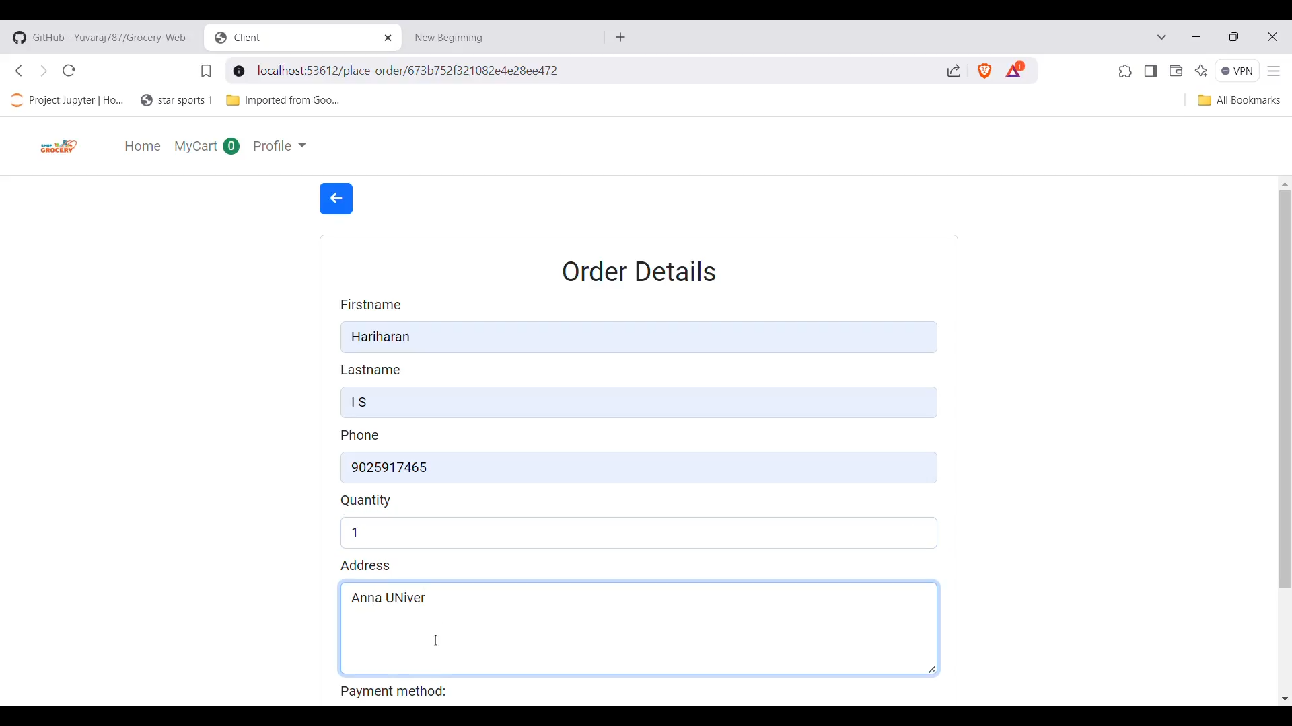

**Fig .9 Order Page**

**Feedback Page**

The Feedback Page provides users with a platform to share their experiences and suggestions about the Grocery Web Application. It features a straightforward form where users can describe their feedback in detail, including their thoughts on product quality, website functionality, or customer service. Users can select feedback categories (such as product issues or general suggestions) to help streamline responses. Additionally, they can upload images or screenshots to illustrate their points more effectively. This page fosters open communication, demonstrating the platform’s commitment to continuous improvement and enhancing user satisfaction by valuing customer input.

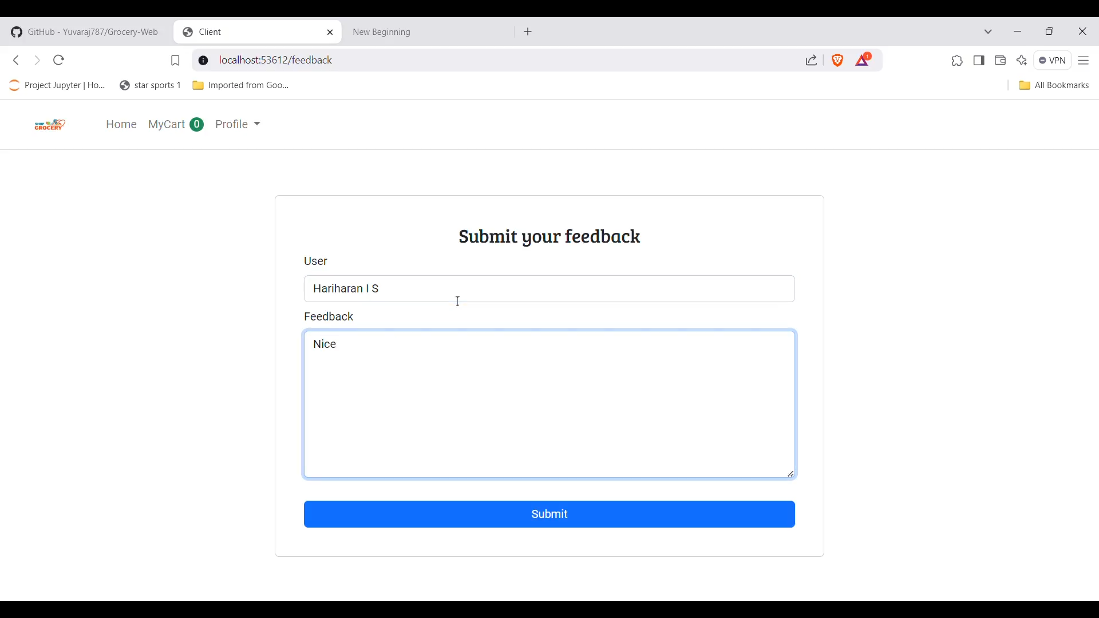

**Fig .10 Feedback Page**

**Conclusion:**

The Grocery Web Application’s web pages are designed for seamless navigation and an engaging user experience. Each page serves a specific purpose, ensuring users can easily browse, purchase, and manage their orders. Together, these components create an efficient and user-friendly platform that meets the needs of both customers and administrators.